Association of Smoking with Cost in a Simulated Dataset for HRP 203

Vikram Fielding-Singh, MD, JD

## Background

Smoking is associated with numerous cardiovascular risk factors.1,2 It may also be associated increased health care costs, although some have suggested that smoking cessation will be associated with increased health care costs.3 In order to practice using reproducible methods, we conducted a study to evaluate whether smoking is associated with increased health care costs in a simulated dataset.

## Methods

We analyzed a cohort of simulated observations with the following variables: smoke, female, age, cardiac, and cost.

We first report descriptive statistics for the cohort and analyze the unadjusted relationship between smoking and cost. To account for possible confounders, we also fit a linear regression model:

$cost_{i}=β_{0}+β_{1}smoke_{i}+β_{2}female_{i}+β_{3}age_{i}+β_{4}cardiac_{i}+ϵ_{i}$

for $i=1,...,n$. Analysis was conducted on June 1, 2025.

## Results

There were 5,000 simulated observations, of whom 2,774 / 5,000 (55.5%) were female (Table 1). The mean age was 43.9 (standard deviation 15.1) years. The average cost in the cohort was $9166 (standard deviation $421), with an average cost of $9663 among smokers and $9072 among nonsmokers (Figure 1). Average costs were $9334 (standard deviation $409) among males and $9031 (standard deviation $380) among females (Figure 2). Finally, increasing age was associated with increased cost (Figure 3).

In adjusted analysis, smoking was associated with $542 (95% confidence interval $526 to $558) of additional cost.

## Discussion

We report a brief analysis examining the relationship between smoking and cost in a simulated dataset. In both unadjusted and adjusted analyses, smoking was associated with higher costs. We also demonstrate several features of reproducible reports, including in-line citations using citation style language to specify the format, relative file paths, embedded code for analyses with linked tables and figures, and inline math notation.

## Generative AI Statement

No generative AI technology was used to complete any portion of this assignment.

## References

1. Virdis A, Giannarelli C, Neves MF, Taddei S, Ghiadoni L. Cigarette smoking and hypertension. *Curr Pharm Des*. 2010;16(23):2518-2525. doi:[10.2174/138161210792062920](https://doi.org/10.2174/138161210792062920)

2. Prochaska JJ, Benowitz NL. Smoking cessation and the cardiovascular patient. *Curr Opin Cardiol*. 2015;30(5):506-511. doi:[10.1097/HCO.0000000000000204](https://doi.org/10.1097/HCO.0000000000000204)

3. Barendregt JJ, Bonneux L, Maas PJ van der. The health care costs of smoking. *N Engl J Med*. 1997;337(15):1052-1057. doi:[10.1056/NEJM199710093371506](https://doi.org/10.1056/NEJM199710093371506)

## Tables

###### Table 1. Cohort Characteristics by Smoking Status

|  | Total (N=5000) | Nonsmoker (N=4211) | Smoker (N=789) |
| --- | --- | --- | --- |
| **Age** |  |  |  |
| Mean (SD) | 43.9 (15.1) | 44.0 (15.1) | 43.4 (15.0) |
| Median [Min, Max] | 44.0 [18.0, 70.0] | 44.0 [18.0, 70.0] | 43.0 [18.0, 70.0] |
| **Gender** |  |  |  |
| Male | 2226 (44.5%) | 1873 (44.5%) | 353 (44.7%) |
| Female | 2774 (55.5%) | 2338 (55.5%) | 436 (55.3%) |
| **Cardiac** |  |  |  |
| No | 4750 (95.0%) | 4094 (97.2%) | 656 (83.1%) |
| Yes | 250 (5.0%) | 117 (2.8%) | 133 (16.9%) |
| **Cost** |  |  |  |
| Mean (SD) | 9170 (421) | 9070 (355) | 9660 (395) |
| Median [Min, Max] | 9140 [7880, 10800] | 9070 [7880, 10300] | 9650 [8650, 10800] |

## Figures

###### Figure 1. Cost by Smoking Status

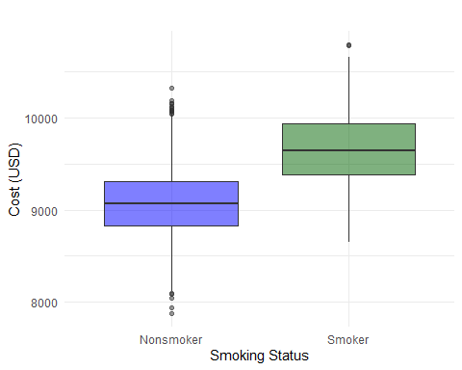

###### Figure 2. Cost by Gender

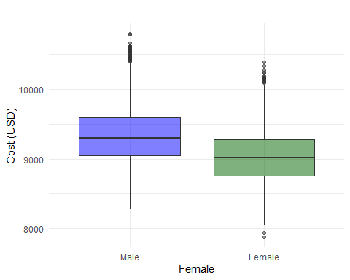

###### Figure 3. Age versus Cost

